WEEK 5
MODULE 9

Problem 1: Initial ERD:
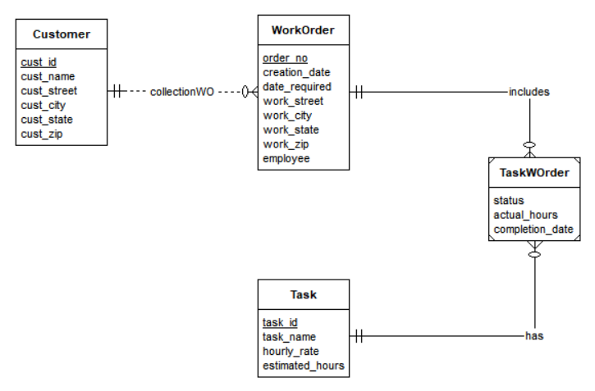

Problem 1: Revised ERD:
